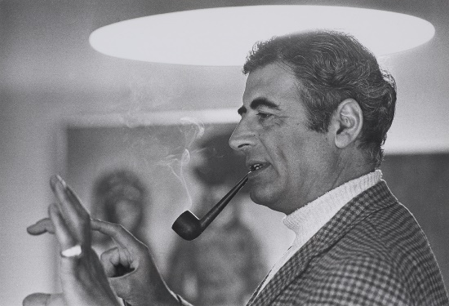
Andrew Grima
(31 May 1921 – 26 December 2007) was an Anglo-Italian jewellery designer.

https://en.wikipedia.org/wiki/Andrew_Grima

Grima was born in Rome to Italian-Maltese parents and grew up in London. He studied mechanical engineering at the University of Nottingham. The family was artistic and creative. After the word war II, he started work in his father-in-law's jewellery firm in London, Haller Jewellery Company Limited (H.J. Co) initially in the accounts department, before moving into design. https://en.wikipedia.org/wiki/Andrew_Grima
The father of modern jewellery, the golden engineer, the King of Bling... These are just some of the epithets assigned to Andrew Grima, the British genius who marched in the vanguard of a 1960s London-based movement that created a new vocabulary for jewellery design. Jeweller to the royals and the jet set, to the rule makers and the tastemakers. https://grimajewellery.com/the-book/

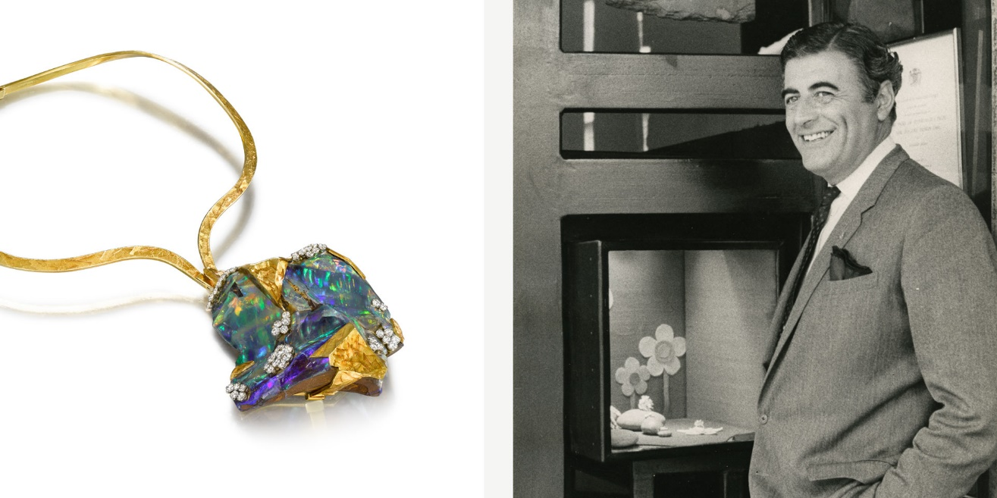
https://www.winterson.co.uk/blog/impressionist-jewels-andrew-grima/

One of a handful of designers who revolutionized British jewellery in the early 1960s, Grima didn't learn his trade at art school, being entirely self-taught and never trained at the jeweller’s bench. He considered being a pure designer to be an advantage – his imaginative ideas were never confined by technicalities or ingrained concepts of what constituted fine jewellery. https://www.winterson.co.uk/blog/impressionist-jewels-andrew-grima/
His outstanding jewellery won the patronage of royalty and international celebrities such as Queen Elizabeth II, Princess Margaret and Jacqueline Kennedy. https://timesofmalta.com/article/Jewellery-from-the-Maltese-islands.463771
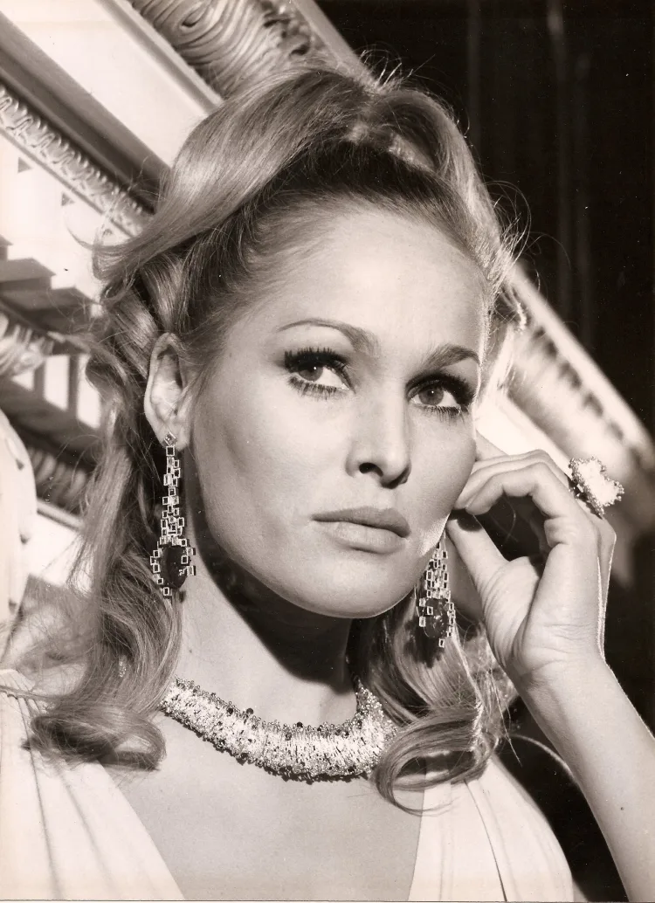
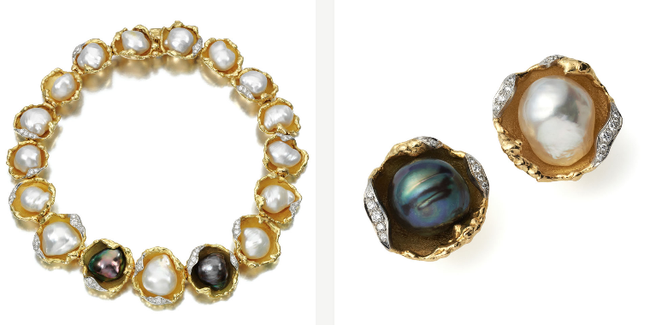
He created bold and unusual jewels whose value lay in their aesthetic composition rather than just in the carat weight of expensive diamonds and precious gems. His journey began with a large cache of natural Brazilian stones - aquamarines, citrines, tourmalines and rough amethysts – that became a trademark for the young designer. Scouring the natural world for textures – bark, shell, moss – he created abstract shapes with rough stones. His interest in natural forms extended to a love of both opals and pearls, which featured regularly in his work. Each of the gems is defined by individual uniqueness in the way that they are formed – no one piece looks quite like another in terms of fire or, in the case of pearls, lustre and overtone. https://www.winterson.co.uk/blog/impressionist-jewels-andrew-grima/
Ursula Andress
wears Grima jewellery, winners of the Duke of Edinburgh Prize for Elegant Design in 1966
https://www.winterson.co.uk/blog/impressionist-jewels-andrew-grima/

https://www.winterson.co.uk/blog/impressionist-jewels-andrew-grima/

“Andrew Grima’s work is distinct in terms of its design, quality and originality,” says Emily Barber, Director of Bonhams Jewellery. “He was essentially an artist whose medium happened to be jewellery. His designs capture the spirit of each era in which he worked yet are still immensely wearable and contemporary today.”
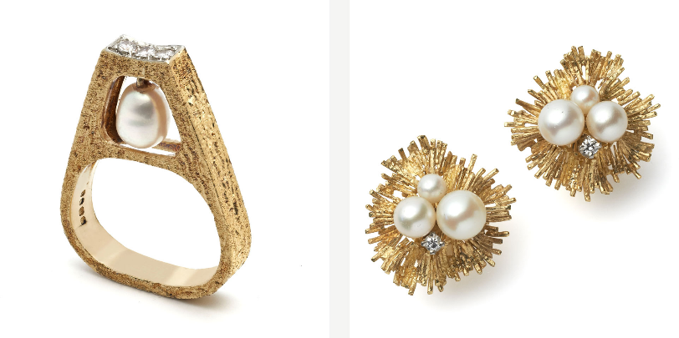

https://www.winterson.co.uk/blog/impressionist-jewels-andrew-grima/

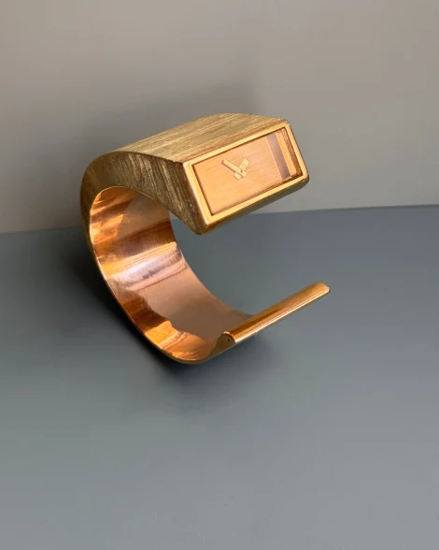
In 1970 he designed the "About Time" watch collection for Omega and in 1976 a collection of gold digital LED watches for Pulsar. https://en.wikipedia.org/wiki/Andrew_Grima
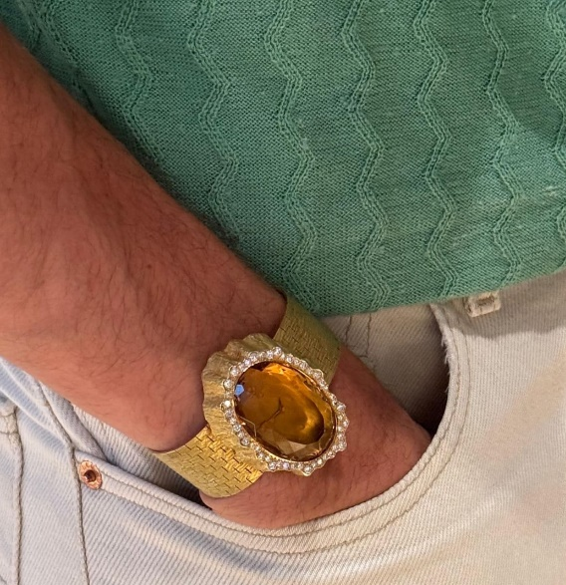
From Andrew Grima's "About Time" collection for Omega. "Utopia" Watch, 1970
"Utopia" features a rectangular smoky quartz glass on a brushed 18ct. textured yellow gold bangle. https://grimajewellery.com/the-collection/watches/

From Andrew Grima's "About Time" collection for Omega.
GRIMA, "Linenfold" Watch, 1969

"Linenfold" features an oval ctirine glass weighing 76.13cts. surrounded by an irregular pattern of diamonds. The case is 18ct. textured yellow gold with a wide bracelet. https://grimajewellery.com/the-collection/watches/

No counters to form a barrier between customer and salesperson, clean lines, no clutter—everything designed to lead the customer toward the jewels". https://en.wikipedia.org/wiki/Andrew_Grima

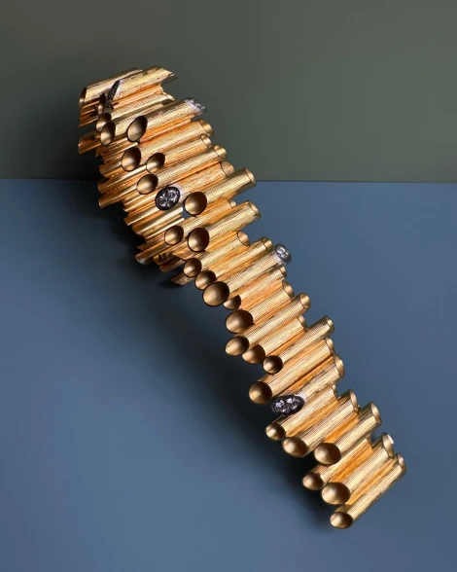

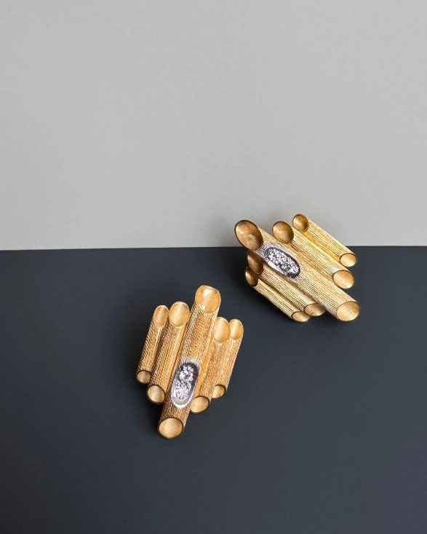

Tube Bracelet, 1972
18ct. yellow gold line engraved tubes,
some accented with diamonds.

Tube Earrings, 1975
18ct. yellow gold line-engraved tubes set with diamonds.
https://grimajewellery.com/the-collection/bracelets/

Since Andrew’s death in 2007, his wife Jojo and daughter Francesca continue the tradition of creating highly original handmade jewellery. A limited collection of 20 to 30 pieces is created each year as only a handful of goldsmiths, most of whom have been employed by Grima for over 40 years, possess the skills required to make these unique pieces. Jojo and Francesca also accept requests for bespoke designs and offer a large selection of vintage pieces. https://grimajewellery.com/about-grima/our-story/

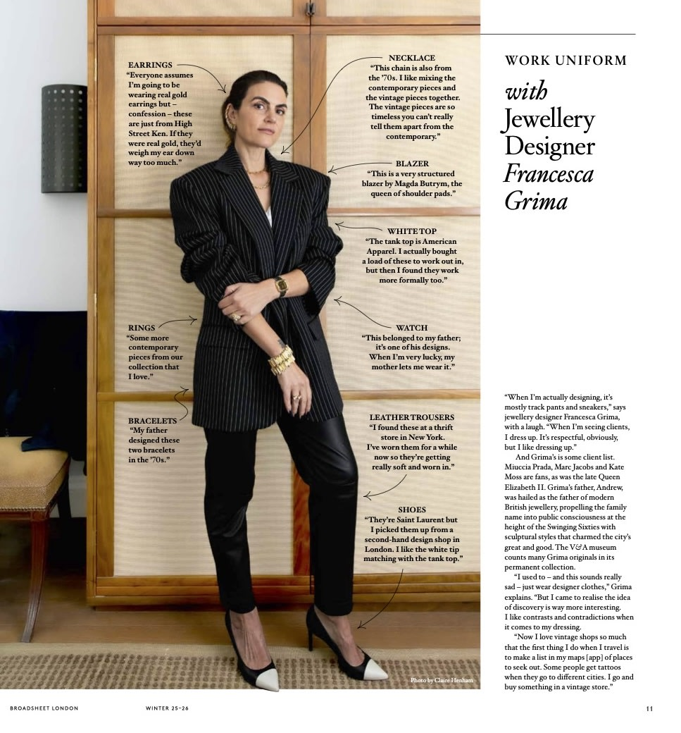

https://grimajewellery.com/press/60-broadsheet-london/

Lähteet:
https://en.wikipedia.org/wiki/Andrew_Grima
https://grimajewellery.com/the-book/
https://grimajewellery.com/
https://www.winterson.co.uk/blog/impressionist-jewels-andrew-grima/
https://timesofmalta.com/article/Jewellery-from-the-Maltese-islands.463771
https://grimajewellery.com/about-grima/our-story/

