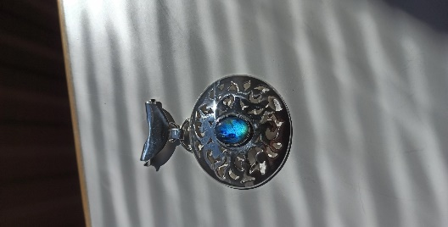
Practice work
Midsummer
Jewellery Design

We are well known Goldsmith's Workshop, and we have clients from all over the world. Our unique jewellery has earned their place in our clients’ hearts. We sell silver, gold and copper jewellery, make jewellery for customer’s needs, prepare old ones and make maintenance work with professionalism.
We offer immediate information and advice for customers in various situations concerning jewellery.

Midsummer Jewellery Design
We start planning from a theme by thinking about the topic from a broader perspective, such as "What do one do? What is the situation?" We can think about the different seasons and the moods of the theme. We can together think about what theme means to the customer, what should the jewellery look like, feel and what kind of a purpose a jewellery is acquired. There will be lots of sketches customer can pick at will.

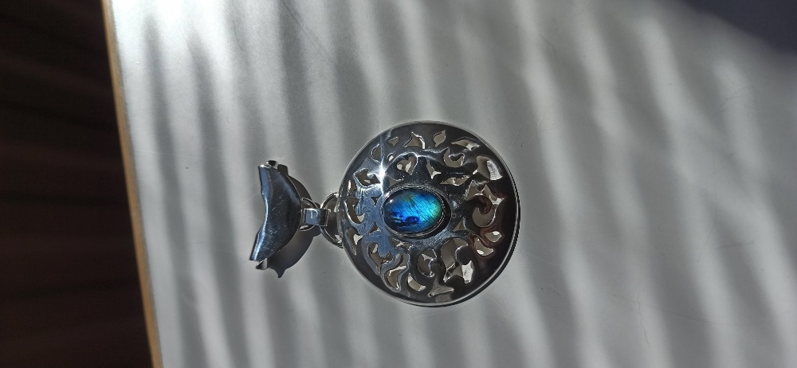

MD

Our Midsummer pendant is handcrafted in Finland from 925 silver. The jewellery is crowned with an 8 mm blue shimmering stone. The stone is a rare spectrolite honed in Finland. Midsummer Night pendant hides a precious memory of the dancing lovely people. There is lots of love and friendly people relaxing and enjoying the time to be together.
This Midsummer pendant cots 450 euros and with a silver bracelet 500 euros. The delivery costs are added. Our delivery time is 1 month, and you can choose suitable payment method from below.
Our jewellery has all guarantees under the Consumer Protection Act. You can get significant benefits and discounts of buying several pieces of jewellery.

We are happy to invite you to join our customer base and to give you all information needed.
You can find us www.midsummert.com
Midsummer design
Midsummer ltd, PL 20, 37830 Akaa, midsummer(at)gift.com

